Draft IAMP Biomass Sampling Protocol 2024
Biomass sampling is a useful metric for correlating nitrogen uptake in plants with the nitrogen available in the soil. The samples taken here will be sent for Carbon: Nitrogen analysis, which is an indicator for crop health and eventual yield estimates. The values from the biomass samples will be associated with the values given from the soil samples early in the season. (I wasn’t sure exactly what to mention here, since I am unsure of the end results for this biomass/paired soil sampling data)
Equipment:
- A bag to hold biomass: This can be a paper shopping bag, a reusable bag you would take to the store, whatever you have.
- A rice knife, handheld scythe, serrated knife, or other cutting implement: A rice knife will work best for harvesting grasses like winter wheat.
- Scissors or gardening shears will work best for harvesting things like cover crops with thicker stems.
- Meter stick or PVC pipe cut to the length of 1 meter
- A handheld weighing device (like a luggage scale) or a kitchen/farm scale that has units in grams, or pounds and ounces.
- Gloves
- 1-quart Ziplock/plastic sample bag
- Sharpie for labeling

Sampling protocol:
- Identify the Business as Usual and treatment sites. This will be near where each producer has taken soil samples. See the IAMP Soil Sampling Protocol to learn more about site selection. We will want our producers to take biomass samples at the same locations where the soil samples were collected. This will give a direct correlation between the soil sample and biomass samples for nitrogen use and uptake. GPS coordinates should be documented in the application.
- Identify a target crop row for each of the BAU and treatment sites. This should be fairly easy in a minimal to moderately weedy site, but for high density weeds, you may need to look specifically for your target crop/plant. Identify the parallel lines where crops were seeded. If there is no visible crop row, it is possible the site was seeded twice. This is useful information to document about the site, and should be put into the app. If it was double seeded, there is also the possibility of a double application of fertilizer as well.
- Measure the distance between the crop rows in centimeters or inches. This should align with the seeder/disk/drill distance on the producer’s seeding equipment. Document this distance and put it in the app.
- Lay down your 1-meter stick/PVC pipe parallel to the crop row. Ensure the area you are in is representative of the field. i.e. do not choose a section of the crop row that is particularly patchy if there is a good stand in the rest of the field, and vice versa.
- Begin cutting the biomass with the rice knife as close to the surface of the soil as possible. Ensure all biomass makes it into the bag, even weeds. These are considered biomass as well and will be using nitrogen similarly to the target crop.
- Place the cut biomass into the sample bag. Biomass can be compacted to fit it more easily into the sample bag.
- When the crop row is entirely harvested, weigh the bag of biomass. Put this information into the app under “Weight of full bag”.
- Take a subsample of the biomass. Mix around all the plant material in the bag, and then take a handful. Place this into the Ziplock bag, and label it with the field information.
- Discard the remaining biomass within the sample bag.
- Weight the empty bag. Document this information in the app under “Weight of empty bag”.
- Replicate this protocol three times.
- A video documenting the process of biomass sampling and documentation can be found <here Still finalizing video>
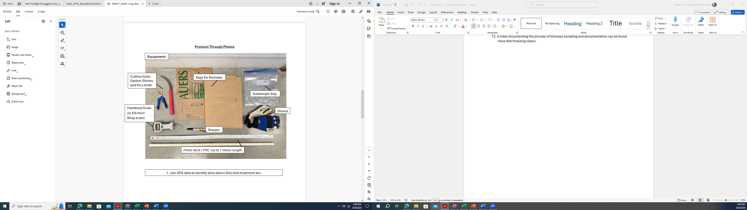
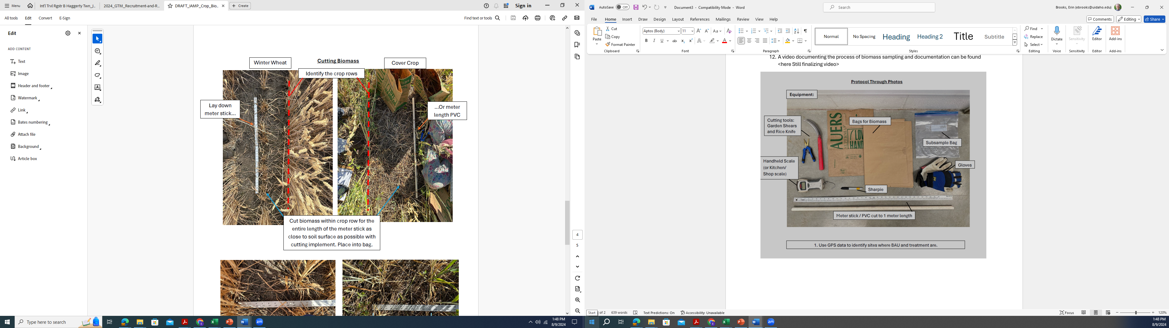
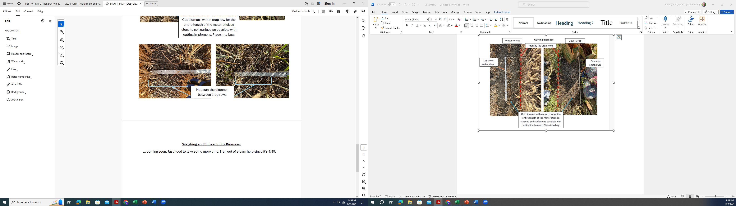
Weighing and Subsampling Biomass:
… coming soon.

