IAMP Soil Sampling Protocol.
One of the primary goals of the IAMP project is to track changes in soil carbon stocks and reductions in Greenhouse Gas Emissions in response to changes to adopted crop management strategies. Soil carbon stocks can be measured directly through soil sampling. Greenhouse Gas Emissions are more difficult to measure however it has been shown that reductions in nitrous oxide emissions (N₂O) are highly correlated with nitrogen uptake efficiency of a cropping system. Therefore we are requiring soil carbon and soil nutrient analysis to be taken from each field enrolled in the IAMP project.
Since soil carbon stocks change slowly over time the IAMP project is only requiring soil carbon measurements be made the first and last year of the IAMP contract.
Soil nutrient analysis will be taken prior to planting and in some cases after harvest of the crop. These soil samples will be analyzed for either a complete fertility test or a basic fertility test depending on practice and date and will be used to assist in determining soil fertilizer rates and assessing nitrogen uptake efficiency.
In addition, any manure/compost application to a field should be tested once a year for total carbon and nitrogen.
Some practices require soil sampling at a ‘Business-as-usual (BAU)’ point as well as a ‘treatment’ points where the practice is being implemented. The business-as-usual practice will consist of a minimum of 30 ft x 80 ft strip that will be management using traditional strategies that is sampled as a paired location to the treatment point.
See Tables 1 and 2 in IAMP_required_soil_analysis for a complete listing by practice of the required soil, plant, and manure sampling as well as the practices which require a BAU strip. The following steps describe the procedures for selecting baseline strips and soil sample points, procedures for taking the soil sample, and instructions for shipping samples to appropriate labs.
Equipment required:
- 1 liter Ziplock bags
- A minimum of one 5 gallon bucket (NOTE: A separate 5 gallon bucket for each depth of sample can save time, depends on the preference of the person sampling, see below)
- Soil auger: Recommend getting a 2” soil auger. The cheapest option is a ‘One-piece regular auger (currently selling for $200 at AMS). The “quick connect” augers with different extensions are nice if you think you will ever need to go deeper or would like to replace different auger buckets but are more expensive. Some augers are better for clay soils and others better for sand. A good general auger is below.
2-3/4" One Piece Regular Auger (ams-samplers.com)
Often in the spring soils are soft enough that soil push probes can be used to manually sample at depth. This can be faster than using an auger but it is not a good option when soils are dry or rocky. For those wanted to have an option of a push probe then the following is a simple expensive model to consider. 7/8" X 33" Soil Probe w/ Handle, 5/8" Thread (ams-samplers.com). Finally, for those in the IAMP project near Kimberly or Aberdeen, the University of Idaho has purchased a hydraulic power probe mounted to a UTV that can be possibly borrowed to assist with sampling. Reach out to Xi Liang or Linda Schott about scheduling the use of these power probes. A truck and trailer will be required to borrow this equipment.
- Marking pen to label the bags (perhaps we go to a uniform QR code in the future for IAMP)
Steps:
- Identify the location of the Business-as-usual BAU strip: Commonly it is recommended that growers follow composite soil sample procedures where multiple soil samples are taken throughout a field or region or zone of a field to get a representative soil sample for a large area (see BUL 915 - University of Idaho Extension (uidaho.edu)). We recommend that growers continue to follow these recommendations to fix soil fertilizer rates in a field however for the purposes of the IAMP project we are requiring soil samples to document impacts of the adoption of a management practice at a particular point in a field.

For this purpose planners will be working with growers to select a particular point and strip in a field to make a comparison between the traditional farming approach and the cropping practice incentivized in the IAMP contract. In particular, for tracking changes in soil carbon the IAMP project is interested in documenting changes in soil carbon in a wide range of soils and therefore are encouraging planners who have the option of selecting points from multiple fields across a region to select points in a field that represent unique soil types. We encourage planners to use the following online geospatial tool to assist in classifying fields into multiple zones Soil_Stratifi_Tool. Alternatively planners can use the web soil survey Web Soil Survey - Home (usda.gov) to guide the selection of baseline strips.

The Soil Stratifi Tool breaks up a region into multiple zones based on preselected criteria including soil attributes, topography, and satellite imagery. The tool allows users to 1.) select the criteria for classifying zones in a region, 2.) define the number of classes to break the region into, and 3.) provides GPS coordinates of soil sampling points if desired. We recommend planners work with growers to select the location of the baseline BAU strip and the paired soil sampling points using this Stratifi tool. We recommend planners select “NDVI”, “Organic Matter”, “Bulk Density” “Soils GSSURGO”, “Elevation”, and “Slope” as criteria to classify the region into zones. We recommend that planners select three “strata” to provide three unique zones within the region, see Figure 1.

The planner can then create a “user defined polygon” a ‘draw’ a polygon shape that encompasses the field(s) area and then click “Run Stratification”. At this point the online tool will break up the region into three zones and display these zones on the screen, see Figure 2. The planner and grower can then decide where to locate the baseline strip in each field with the understanding that if multiple fields are enrolled that it is desirable to take soil samples from unique stratification zones or soil samples in each field. These baseline strips can be located at a location that is convenient for the grower to implement the practice. The width of the baseline strip can vary depending on the width of the implements used to farm the field. For example, if the largest implement used to farm a field is a 60 ft boom sprayer then set the baseline strip to 60 ft wide. We request these strips be no more narrow than 30 ft in width in order to utilize available satellite imagery to track differences in the baseline and treatment sites. Planners and growers do not need to sample very minor soil types especially if they are extreme outlier points in a region.

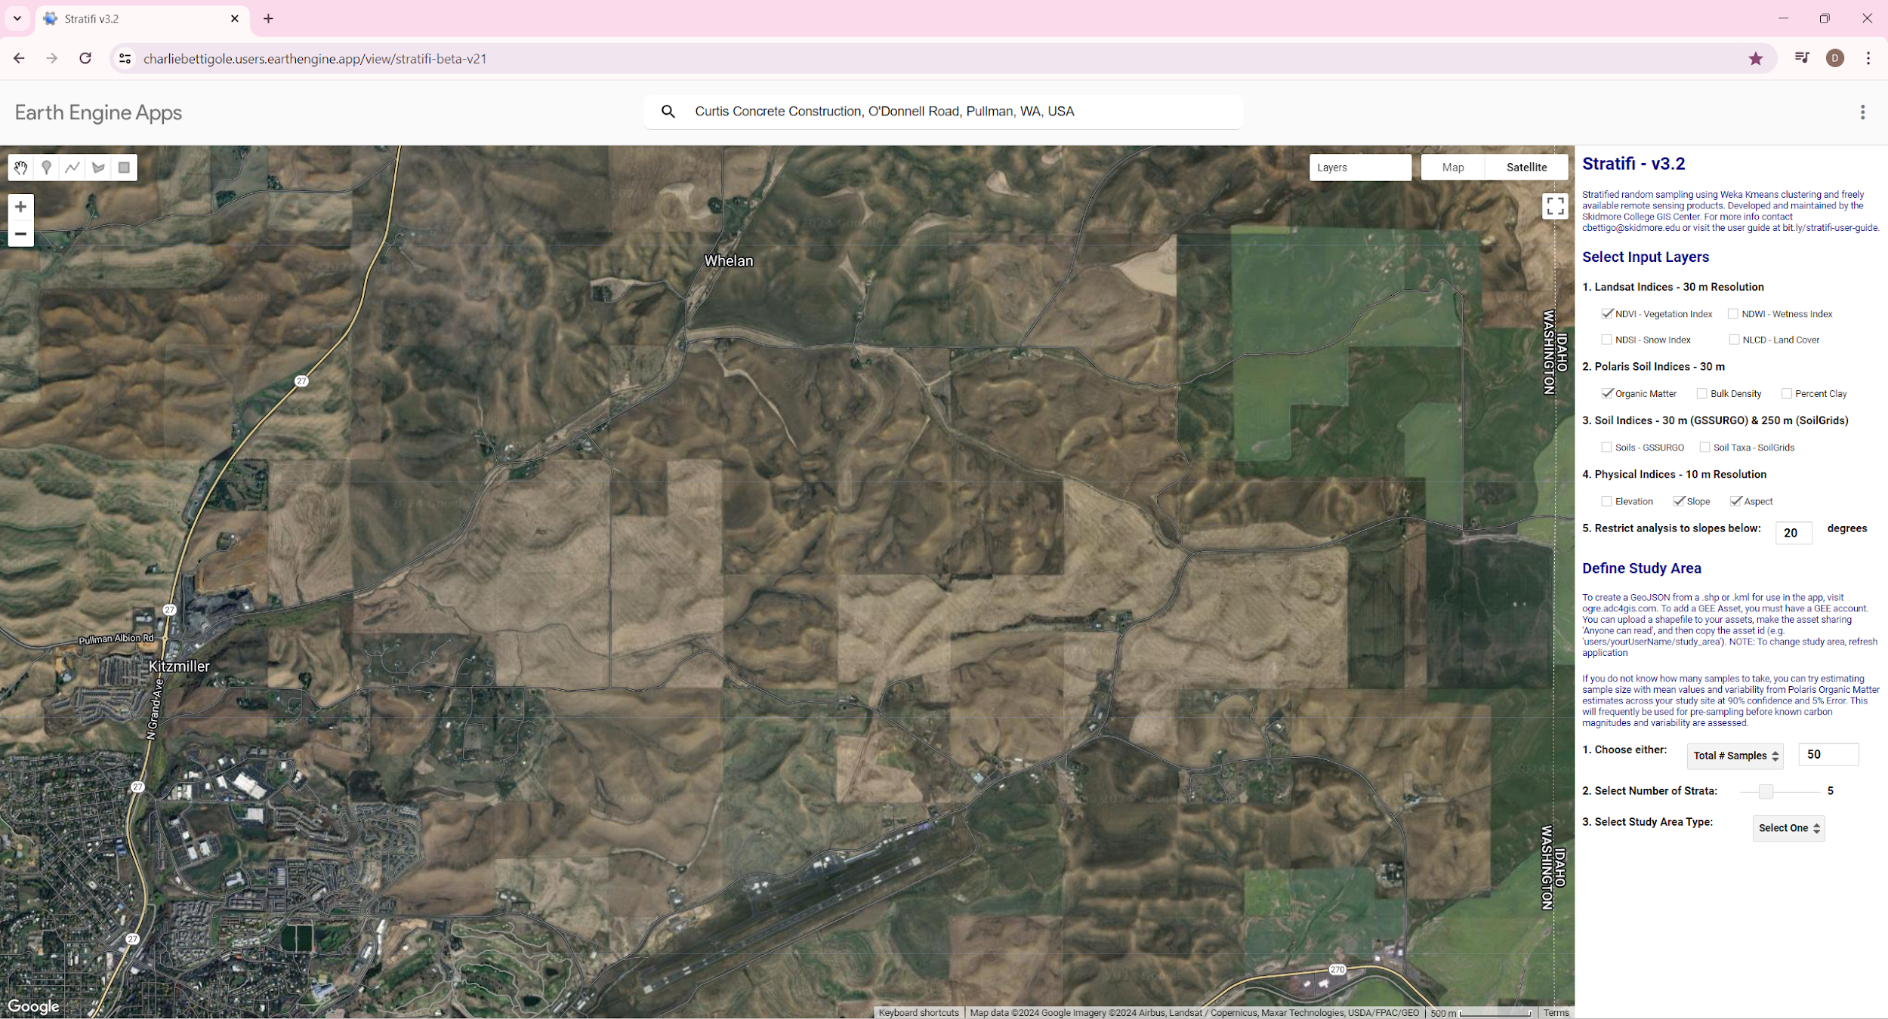
Figure 1. Screen shot of the stratification tool.
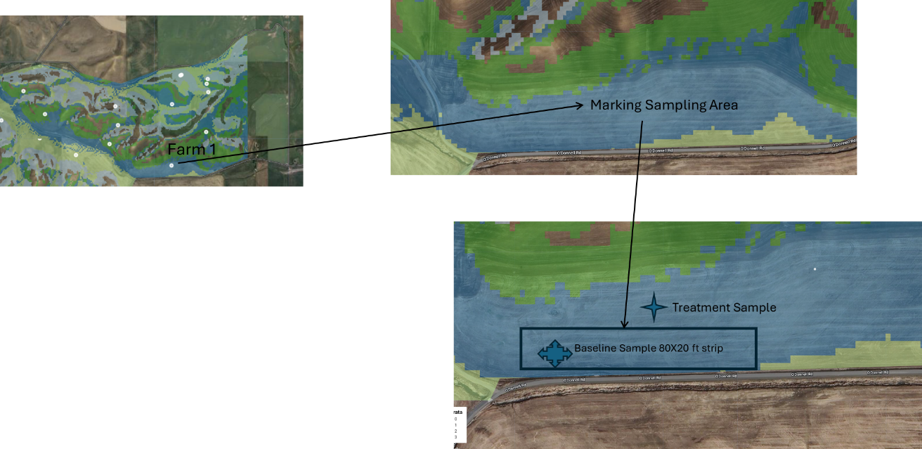
Figure 2. Final stratified field which can be used to select the baseline strip and paired sampling points within the strip.

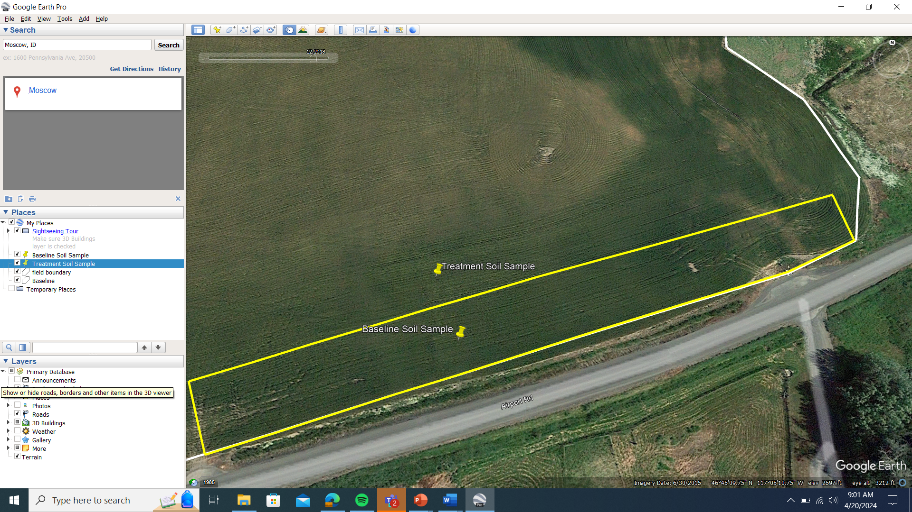
- Identify the location of the paired soil sample points directly within and outside of the baseline strip. Work with the grower to select paired soil sample locations in the middle of the strip and a paired point outside the strip but no more than the width of the strip away from the center of the baseline strip. Note the exact soil sample points can be fixed in the field after agreeing on the baseline strip using the IAMP soil sample phone app IAMP_soil_sampling_app which can be used to record the lat-long coordinate of the soil sample points. Once these soil sample points are identified then subsequent soil sampling should occur at the same location each year and using the same baseline strip.
- Record an image of the ground surface cover: At the center of each paired soil sampling location take a picture straight down towards the soil at roughly a 4 ft height above the ground using the IAMP_soil_sampling_app
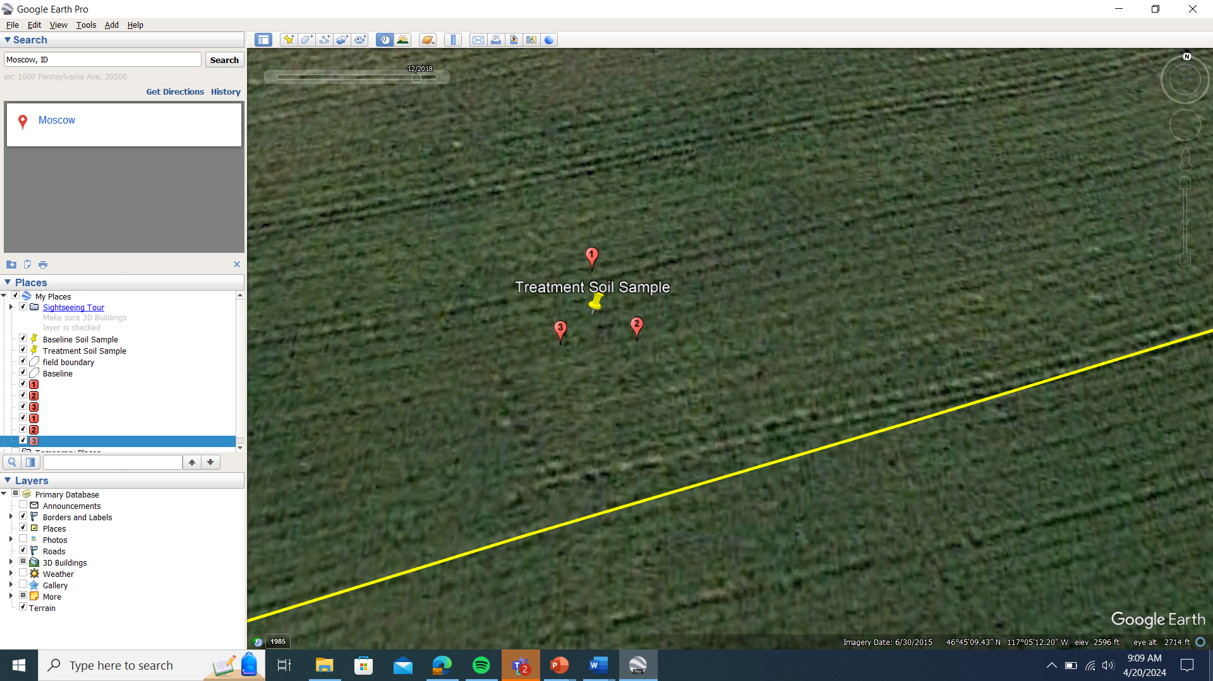
Following the protocols above three sub samples are taken around this georeferenced point (approximately 6 ft North, Southeast, and Southwest of the georeferenced point).

- Identify three points within 6 ft of the georeferenced point to auger holes. A suggestion would be one point 6 ft ‘North’ of the georeferenced point, one point 6 ft ‘Southwest’ of the georeferenced point, and one point 6 ft ‘Southeast’ of the georeferenced point. Note: you will continue to sample from this location throughout the project. One approach to consider is to avoid sampling the exact same location is to rotate these points clockwise by 15 degrees or so each season.
- Take subsamples: As mentioned above soil samples will be taken for nutrient management purposes and for tracking soil carbon stocks. For nutrient management the required soil samples depths are in 1 ft (30 cm) increments down to the depth required for the specific the implemented practice (refer to Tables 1 and 2 in IAMP required soil sampling for specific instructions on the depth of sampling by practice). For soil carbon stock measurements we require separate soil samples from 0-4 in, 4-8 in, 8-12 in, 1-2 ft, 2-3 ft, (3-4 ft and 4-5ft if possible) during the start and end of the grower contract period. Before starting to take a sample, first remove any surface/ground crop residue for the location where you will auger. Then using the auger dig down to the first required soil sampling depth and dumping the soil in the 5 gallon bucket. Sometimes it is easy to use tape to mark the depth increments on the auger rod. Note: the depth is measured from the tip of the auger not necessarily the bottom of the “bucket” section of the auger. If you only have one bucket then proceed to the next hole and take another soil sample and finally the third location, dumping all the contents of the soil in the same bucket. If you have separate buckets for every depth increment then you can simply auger down each foot and dump the soil in the appropriately labeled bucket and proceed to the next location. NOTE: If the grower bands fertilizer into the soil and the soil sampling is to be used for nutrient analysis then we would like triplicate sub-samples taken to avoid biased samples at banded locations. One sample in the crop row/furrow, one sample between the crop rows/furrows and a sample halfway between these samples, see figure3 and 4 taken from BUL 915 - University of Idaho Extension (uidaho.edu) picture below.
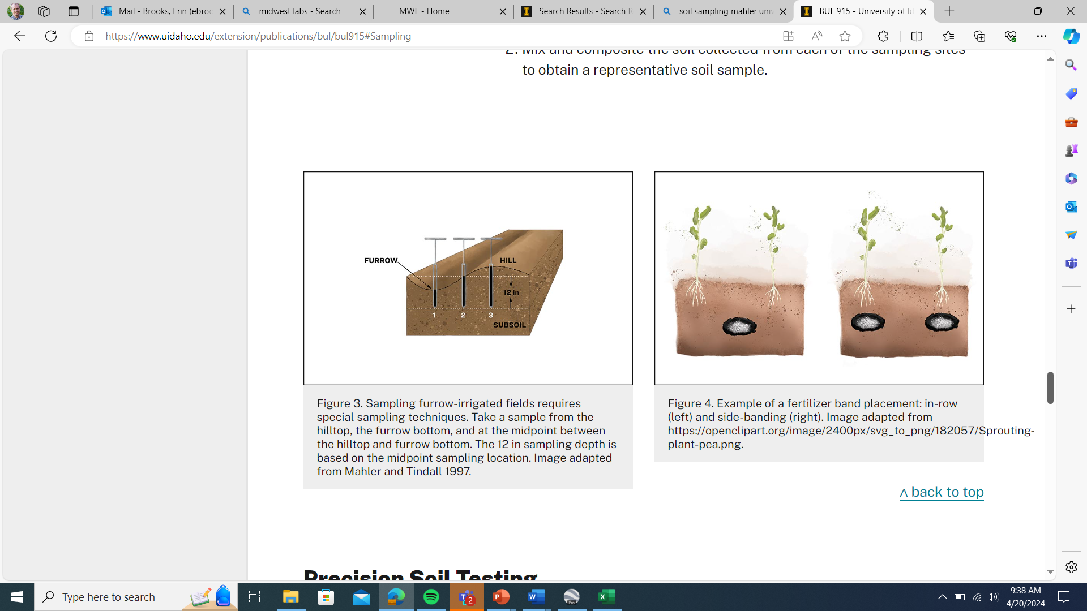

- Mix and take a composite subsample: Either using your hands or other tool, manually mix the soil in the bucket then take a subsample from the bucket and put it in the zip lock bag. Two cups of soil is plenty for soil analysis. Do not completely fill up the zip lock back with soil as the more weight the more cost to ship! (NOTE: if soil samples are being taken for both soil carbon and soil nutrient analysis then we would like the grower to collect two zip lock bags with soil for every depth. One sample should be sent to the University of Idaho for soil carbon analysis, the other sent to the appropriate commercial lab for fertility analysis). Note: If soil samples are being collected both for soil carbon analysis to UI and for nutrient analysis to Midwest labs at the same location (this could be the case in the first and last year of the project) then for the top foot you will need to do a second composite step that allows 0-4”, 4-8” and 8-12” samples to be sent to UI and a composited 0-12” sample to be sent to Midwest labs. We recommend combining the residual soil for the 0-4”, 4”-8”, and 8”-12” depths into a bucket after subsampling for soil carbon analysis, mixing this combined soil and taking a composite subsample representing the 0-12” depth that will be sent to Midwest Labs for nutrient analysis.

- Send samples to lab for analysis: Soil samples be kept cool and should be sent to the appropriate lab within at least 5 days of sampling. If soil samples cannot be sent within 5 days then it is recommended that the samples be spread out and air dried. As described in the spreadsheet IAMP_required_soil_analysis soil samples should be sent to Midwest labs MWL - Home (midwestlabs.com) for fertility analysis. Please take note in the spreadsheet that the 0-1 ft preplant soil sample should be analyzed using the combined ‘extended’ soil fertility analysis and ammonium analysis (specifically this is called the S3C and ammonium-N soil tests at Midwest Labs), and the subsequent deeper samples will be analyzed using the ‘basic’ soil fertility analysis (specifically use the S1A + nitrate-N + ammonium-N soil tests). The post-harvest soil sampling will only require the nitrate-N + ammonium-N soil tests at all soil depths. The duplicate soil sample for the University of Idaho can be sent to the following address:
A recording of the soil sampling procedures described above is available here https://youtu.be/PuqGfRT1jJg
IAMP Project
Department of Soil and Water Systems
University of Idaho
875 Perimeter Dr. MS 2340
Moscow, ID 83844-2340
Attention: Zack Kayler

